**Come Celebrate your Special Day at OOA!**

* A full hour in our Gymnastics area under staff supervision & ½ hour in the party area.
* A $25 non- refundable deposit is required upon booking your party.
* Party Cost- $189 up to 15 guest ($5.00 for each additional guest - **max 22**)
* Please do not arrive early. Parties are booked back to back so please follow times allowed to make sure all parties run smoothly. A fee of $10 for every 10 minutes will be assessed if parties run over time. Please allow staff to clean- up prior party before setting up for your party.
* Due to our insurance policy anyone over the age of 18 is not allow on the Gymnastics Equipment.

**Birthday Party Times**

***Saturday:***

**12:15 to 1:45**

**2:00 to 3:30**

**3:45 to 5:15**

***Sunday:***

**12:15 to 1:45**

**2:00 to 3:30**

**3:45 to 5:15**

1045 SE Paiute Way- Bend, Or. 97702

541.388.5555

[www.ooagymnastics.com](http://www.ooagymnastics.com)

info@ooagym.com

**GYMNASTICS**

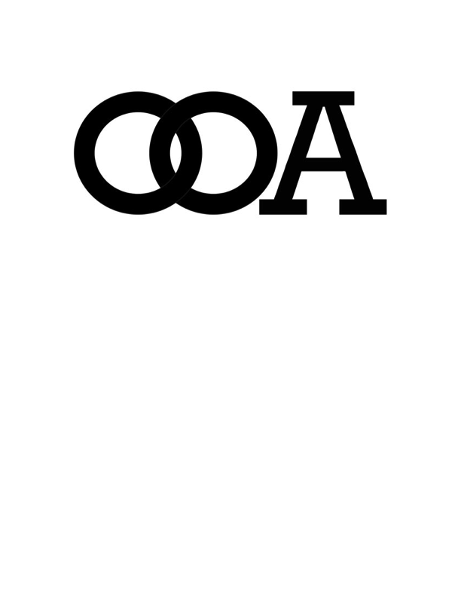

Birthday Child:_____________________________________________________ M F Birth Date:_______________

Contact:_____________________________________________________________Relation:________________________

Address:_______________________________________________________________________________________________

Email:________________________________________________________________Phone:___________________________

Party Date:_____________________________________ Party Time:_________________ to _____________________

Amount Due:________________________________Deposit:_____________________Balance:___________________

NOTES:__________________________________________________________________________________________________